PEER REVIEW this is meant to be a quick review guide so you can have the students interact and look at their maps critically. 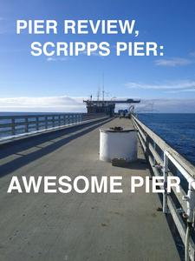

In game design it is important to have unbiased reviews of games. Gaming companies, now more than ever, spend millions on getting the game into gamers hands early on. Think about all the new beta tests coming out and the twitch streamers getting early access. This is a great and often free way to get early opinions on a game and push it to the next level. When we make a game, no matter how mature we are, we bring personal bias. We believe we have an awesome map, but up until we get it in front of a large audience, we can never truly know how well the map will translate to a new audience. Today you get to be part of a small population of testers. Play test each other's game, and write honest and fair feedback. Write things such as “I feel traversing the map is difficult on the upper shelf because the walkways are too narrow” or “my favorite class felt under powered because I couldn’t find good cover in the southern area of the map”. This not only describes why you feel a certain way, but also leads the creator to a better understanding of possible fixes. As a developer reading the review you must take all of them seriously, and understand that there is always room for improvement. Even if the comment bothers you, you must take a look at it, and try to put yourself in the reviewers playing experience. If the feedback does not fit your design philosophy, maybe throw them a bone and include a fix in a different part of the map or address it in a creative way. In the end it is your map, but we want to make as many players happy as possible.

Another important detail to add to a review is the directions. Mention a landmark as a northern point and make sure all your directions follow that. Say something like “ assuming the water tower is the northern part of the map I had trouble traversing the southern crates”. Using landmarks and cardinal directions will really help your developer get to the appropriate area of the map to fix their bug!

GOOD LUCK REVIEWING.

3 things you like about the map:

1.

2.

3.

3 things you would like improved:

1.

2.

3

Additional Comments:

BUGS!

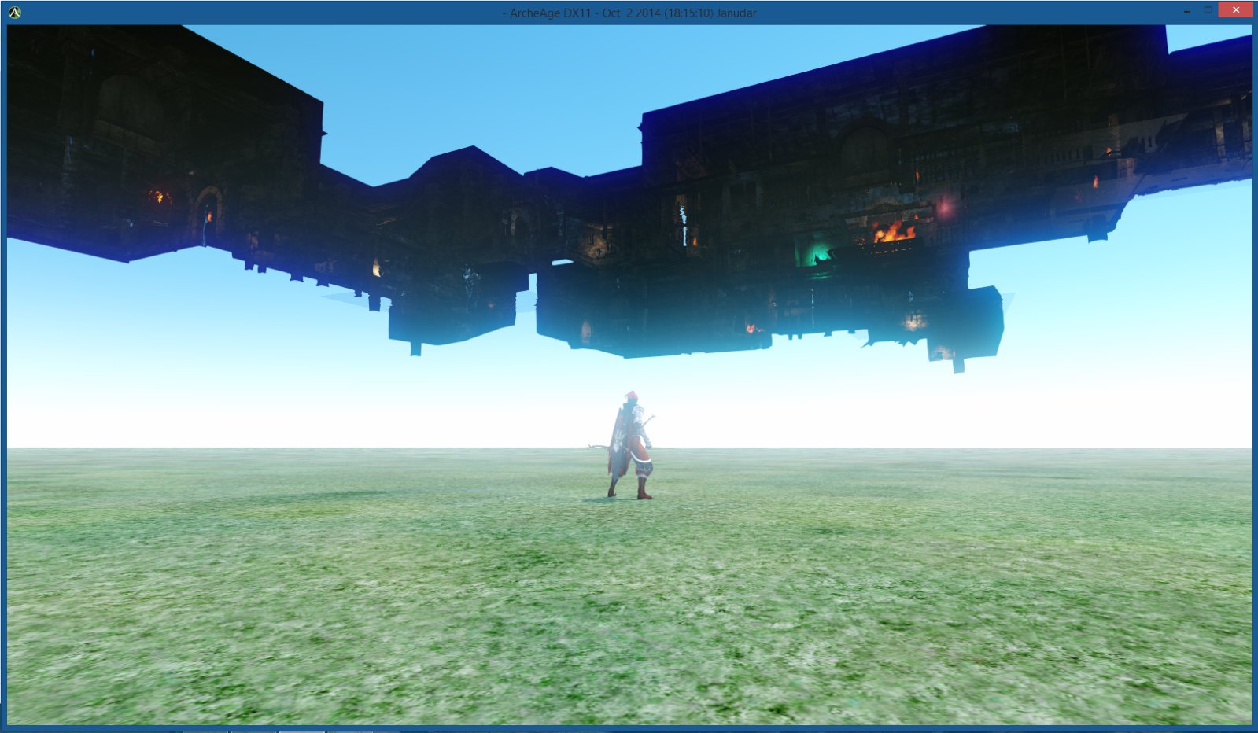

Use the following page to mention any bugs you find with the map or game you are testing. Remember a bug is not supposed to be a piece of personal feedback. A bug is a broken part of the map or game that is acting outside of regular/intended behavior. .

**Good Bug Example:** “ I was able to enter the enemy spawn at the northern section of the map ,assuming the water tower is north, and camp the enemy allowing me to dominate the enemy team before they had time to react”. Notice that the bug described is a behavior we do not want in our map or game. A spawn camper is anti fun and we do not want to be able to enter the enemy spawn. Another good example is a place where one person can see out of but another cannot see in. This is an exploit and should be flagged as a bug!

**Bad Bug Example :**  “ The tower in the middle of the map is an overpowered sniping position! You can clearly see the whole map, and I got sniped multiple times! I think the tower should be moved.” The reason we do not want to report a bug like this is because the bug could not be a bug at all. Maybe this is a king of the hill map and the easily defendable certain point is by design. We cannot assume it is an exploit unless we have direct proof. If there was no part of the map where I could shoot the person in the tower, or the person in the tower could see through a wall to shoot me, then we have a bug. I am using first person shooter examples, because this is what I have the most experience play testing. The ideas are the same for all games. If it is unfair because the game broken it is a bug. If it is a bad design choice, then leave that for the comment section above! Good hunting!

**BUG REPORT**